# Sub task 1

A school pre-primary

Business background

The pre-primary is for children ranging from 3 months to 5 years. So it takes in children to them and get them ready for primary school. Kids community crèche aims to prepare its students to excel as young leaders of tomorrow by combining an exclusive curriculum tailored specifically for children. We offer activities such as arts and crafts, dance, theatre and gymnastics all in one location. Purpose of the database

The database is going to capture the children’s details. It will allow the user to add more names on it, view and delete records if the child has progressed to primary school. It will help them to organise information about the children. It manages data efficiently and allows users to perform multiple tasks with ease.

How the database improves the business functions.

It gives the employees more time to focus on other things because there is less paperwork involved. It will organise the records in a meaningful way, also they will be able to search and find records quickly because there will be less paper work involved.

# Sub Task 2

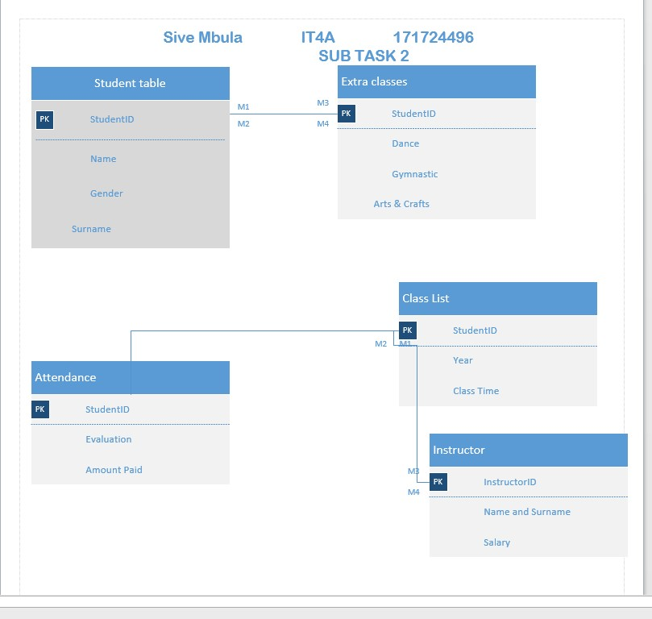

# Sub task 3

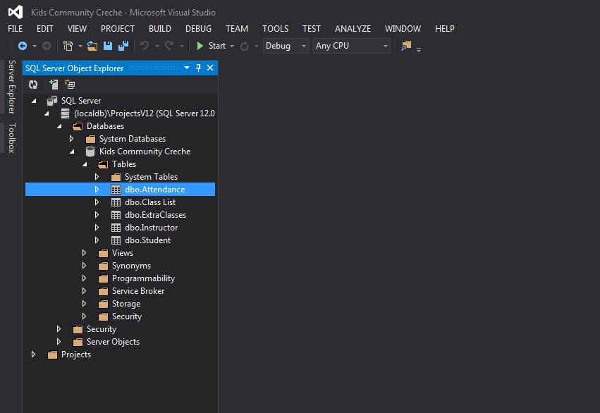

CREATE TABLE [dbo].[Attendance] (

[StudentID] INT NOT NULL,

[Evaluation] NVARCHAR (20) NULL,

[AmountPaid] NVARCHAR (20) NULL,

PRIMARY KEY CLUSTERED ([StudentID] ASC),

CONSTRAINT [CK_Attendance_Column] CHECK (1 = 1)

);

INSERT INTO [dbo].[Student] ([StudentID], [Name], [Surname],

[Gender]) VALUES (20150311, N'Buchule', N'Gomomo', N'Female')

INSERT INTO [dbo].[Student] ([StudentID], [Name], [Surname],

[Gender]) VALUES (20150312, N'Lanwele', N'Gomomo', N'Female')

INSERT INTO [dbo].[Student] ([StudentID], [Name], [Surname],

[Gender]) VALUES (20160210, N'Malikhe', N'Mtako', N'Male')

CREATE TABLE [dbo].[Student] (

[StudentID] INT NOT NULL,

[Name] NVARCHAR (20) NULL,

[Surname] NVARCHAR (20) NULL,

[Gender] NVARCHAR (20) NULL,

PRIMARY KEY CLUSTERED ([StudentID] ASC)

);

GO

CREATE INDEX [IX_Student_Name] ON [dbo].[Student] ([Name])

CREATE VIEW Name_and_Surname As

Select Name,Surname From [dbo].[Student]

;

ALTER VIEW Name_and_surname AS

SELECT Name,Surname FROM Student

WHERE Gender='Female'

;

UPDATE Student

SET Surname = 'Alfred Schmidt', Name= 'Frankfurt'

WHERE StudentID = 20180315;

UPDATE [dbo].[Student]

SET [Surname] = 'Alfred Schmidt', Name= 'Frankfurt'

WHERE StudentID = 20180315;

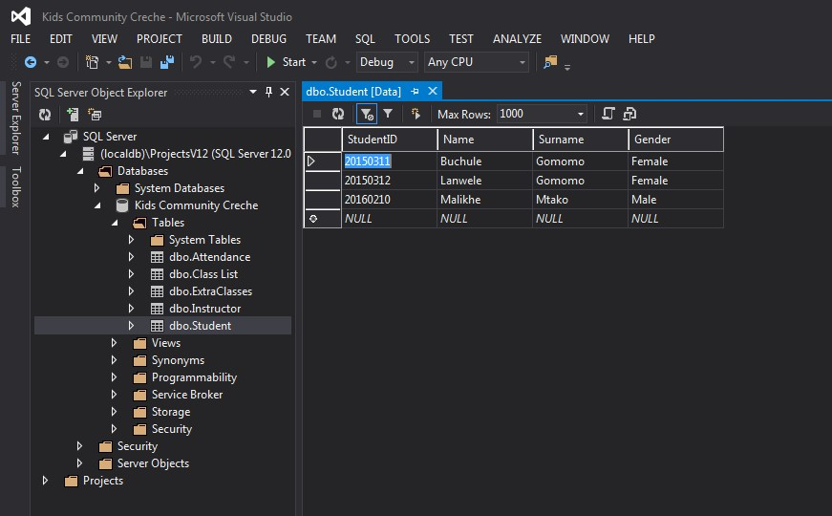

# How to create a backup

1. Open SQL Server Management Studio Express and connect to the SQL server.
2. Expand **Databases**.
3. Right-click on the database you want to back up, then select **Tasks > Back up**.
4. On the Back up Database window, make sure the **Database** field contains the name of the database you want to back up.
5. Select the **Backup Type**. By default, it is **Full** - leave it set to that.
6. Click **Remove** to remove the default/last backup file name.
7. Click **Add** to open the Select Backup Destination window.
8. Click **[...]** next to the File Name field.
9. On the Locate Database Files window, select the folder where you want to backup file to go. By default, it is...**\Microsoft SQL Server\MSSQL.1\MSSQL\Backup**.
10. In the **File Name** field, type the name for this backup, with a **.bak** extension. For example, **xyz_20080221.bak** for a backup of the XYZ database created on 21 February 2008.
11. Click **OK** to close the Locate Database Files window.
12. Click **OK** to close the Select Backup Destination window.
13. Click **OK** to start the backup. The progress icon displays in the lower left corner, and a ‘completed successfully’ message displays when it’s done.